*Owen Lindsey*

*Professor Sparks, James*

*CST-391 TypeScript (Participation)*

*12/5/2024*

**Participation**

*npm outdated:*  
  
This image shows the output of running npm install and npm check-updates commands in the terminal. It highlights several deprecated warnings and a list of 30 vulnerabilities (3 low, 9 moderate, 17 high, 1 critical) in the project dependencies. The npm audit fix and npm audit fix --force commands are suggested to address the issues.  
  
  
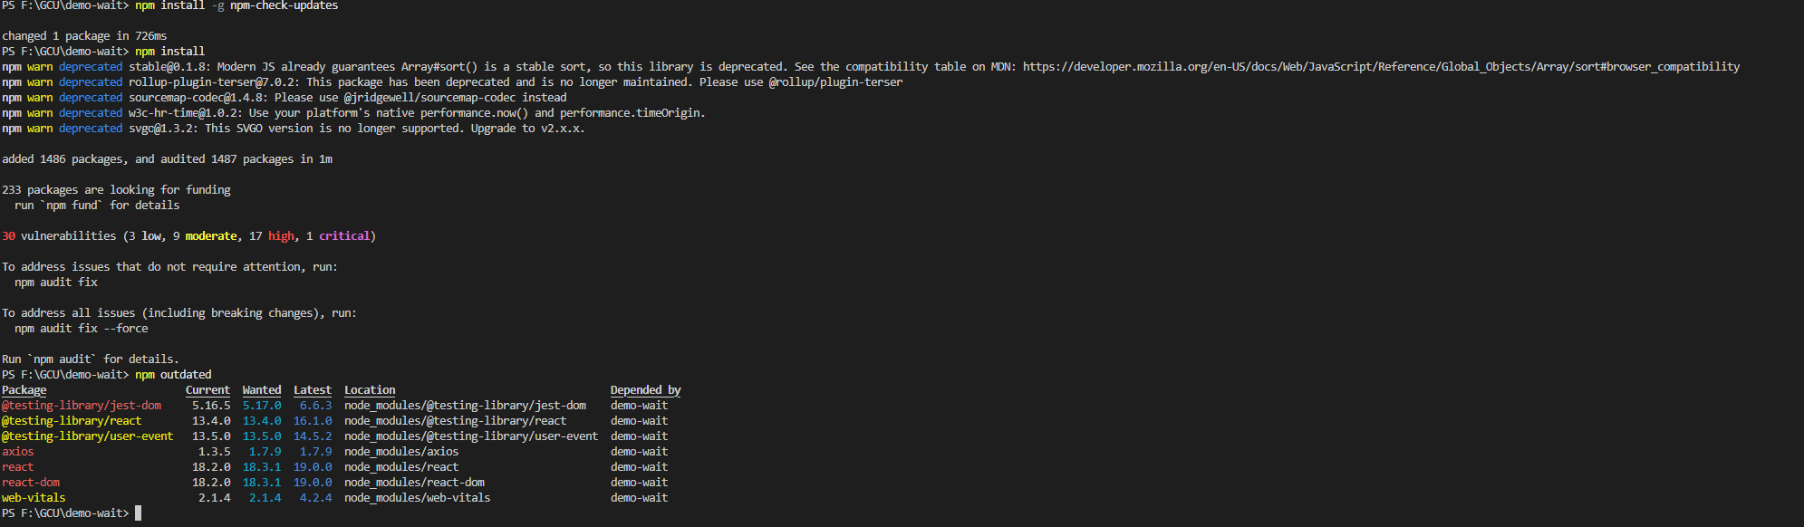

*Ncu-u:*   
  
This image shows the output of running the ncu -u command, which updates the dependency versions in the package.json file. The "Upgrading F:\GCU\demo-wait\package.json" section lists the updated versions for various dependencies, such as @testing-library/jest-dom going from 5.16.5 to 6.6.3, and @testing-library/react going from 13.4.0 to 16.1.0.

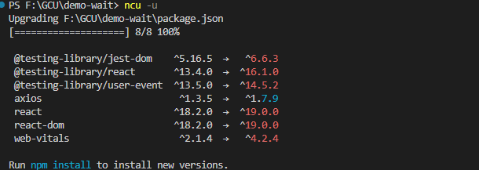

*Npm outdated:*

This image shows the output of the npm outdated command, which lists the current, wanted, and latest versions of the project's dependencies, as well as their locations and the packages that depend on them.

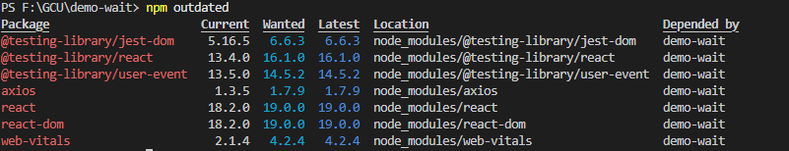  
  
**Participation**

*Npm update / outdated:*

This image shows the output of the npm update command, which has updated the dependency versions in the project. The npm outdated command is then run again, which now shows that all dependencies are at their "Wanted" versions.

the output of the npm outdated command after running npm update. The report is now different, as all dependencies are at their latest "Wanted" versions, and the command output indicates that no outdated dependencies were found.

